**Practical No: 2**

**Build a low fidelity wireframe using any wireframing tool.**

Step 1: Open Figma: Launch Figma and create a new project.

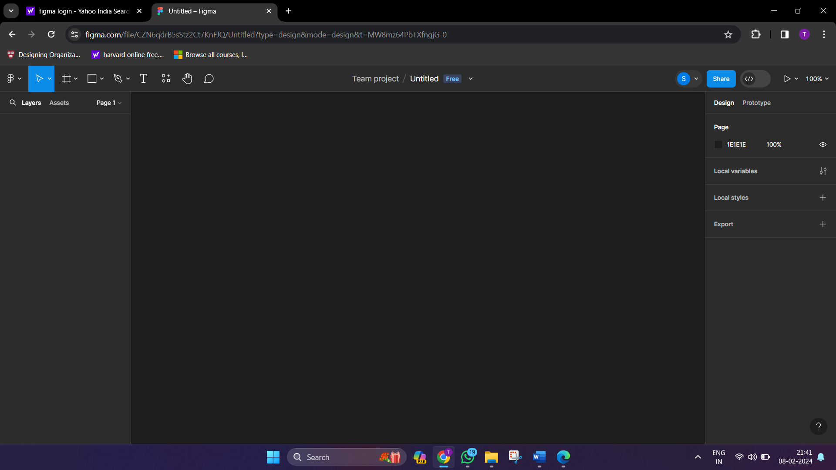

Step 2: Create a new frame to represent your design canvas. Typically, a low-fidelity design focuses on the overall layout and structure.

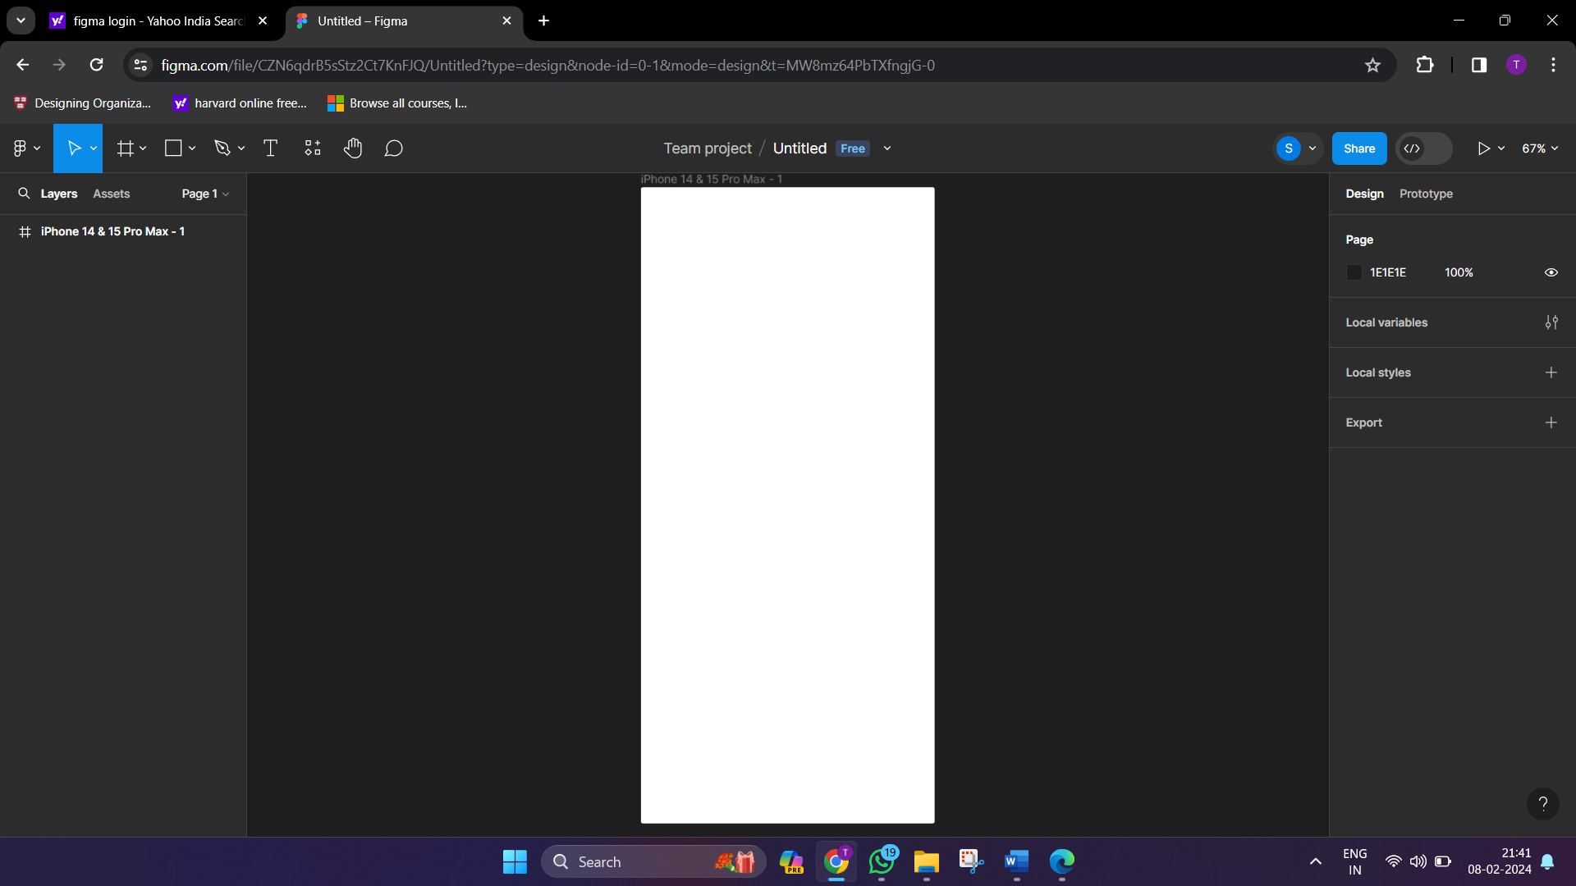

Step 3: Change the page color to any other color as per your likeness, so that we can see our frame easily without any disruption

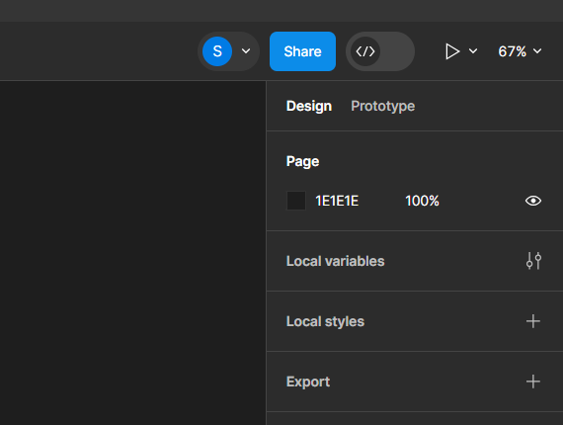

Step 4: Basic Shapes: Use simple shapes (rectangles, circles, etc.) to represent major elements like buttons, images, and text boxes.

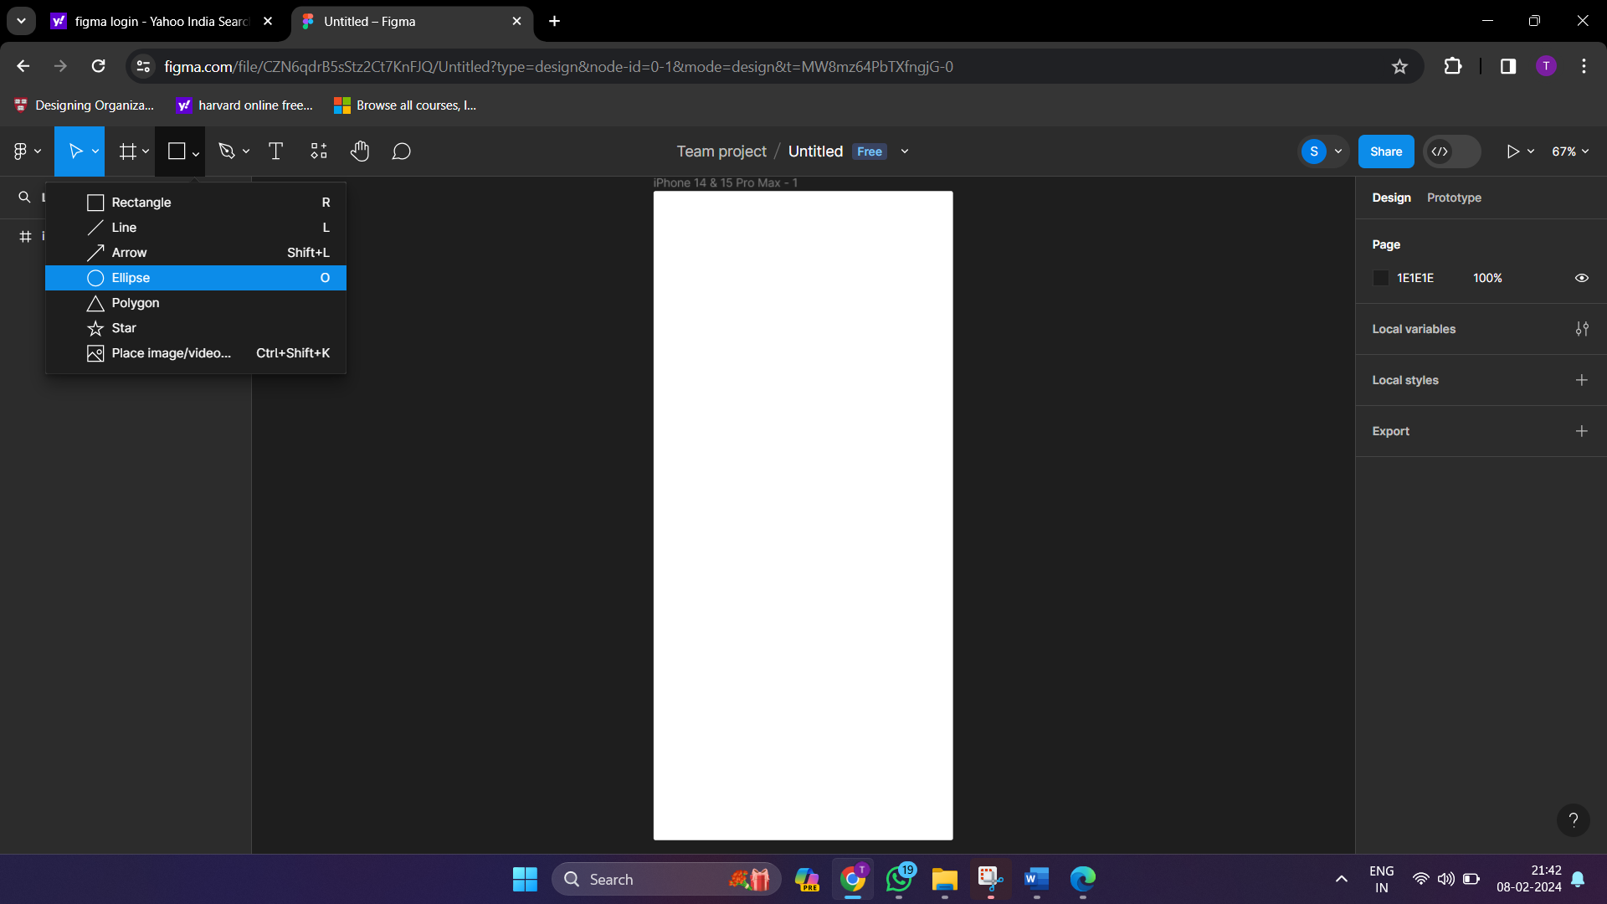

Step 5: Instead of real content, use lines to represent the text, boxes to represent background, cross to represent image and so on.

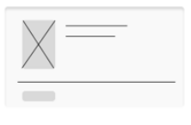

Step 6: Limited Detail: Avoid intricate details at this stage. Focus on conveying the essential components without getting into specifics.

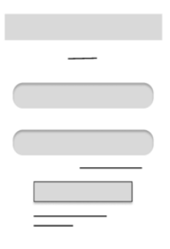

Step 7: Color Palette: Stick to a grayscale or limited color palette

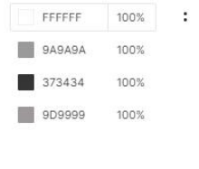

Login Page Home Page

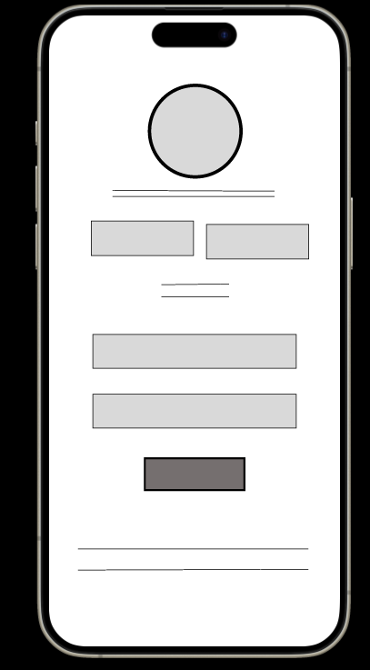 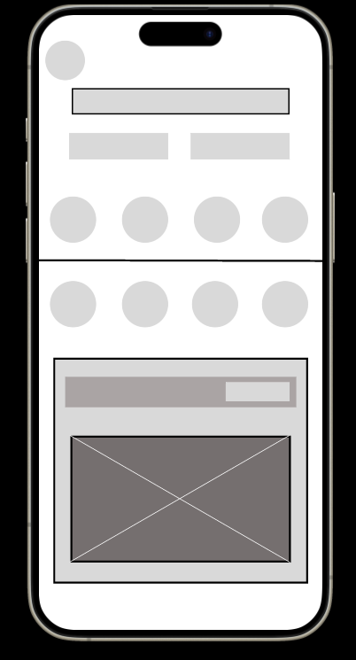

Wishlist Cart View

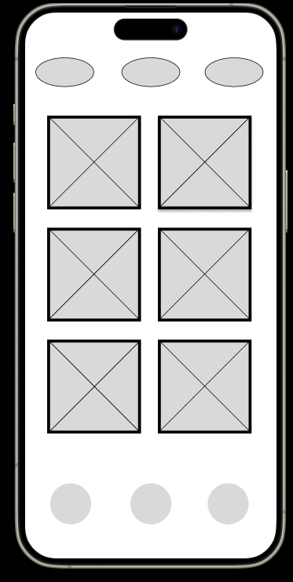 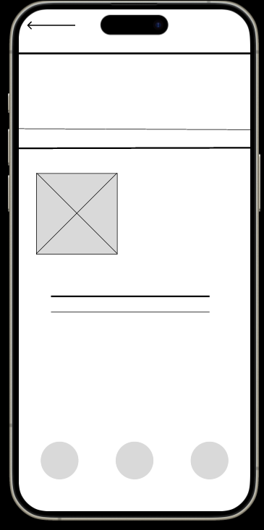

Profile Page Search Page

